**Objective**

In this checkpoint, you're going to practice with a real life example.

After the construction of his hotels in one of the tourist areas, a director wishes to prepare a database to facilitate the management of his data.

The director has presented the following information to you through the entity relationship model.

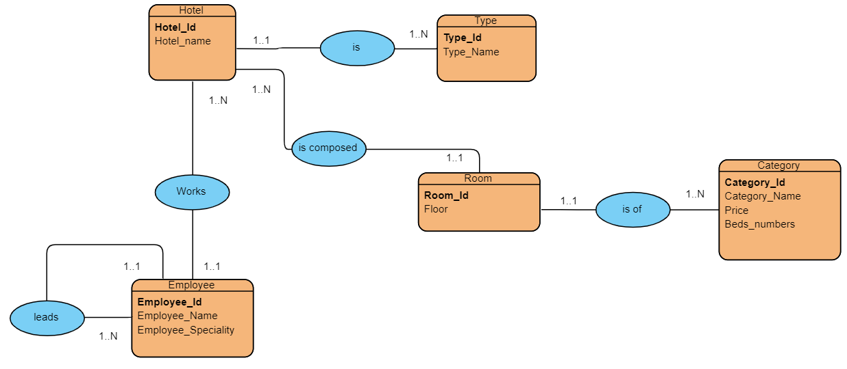

**Instructions**

Convert the  entity relationship model to a relational diagram